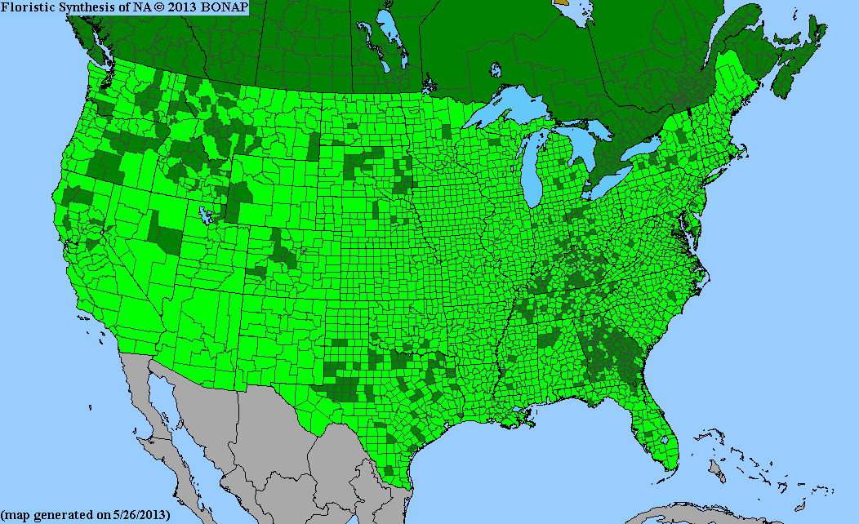Ambrosia

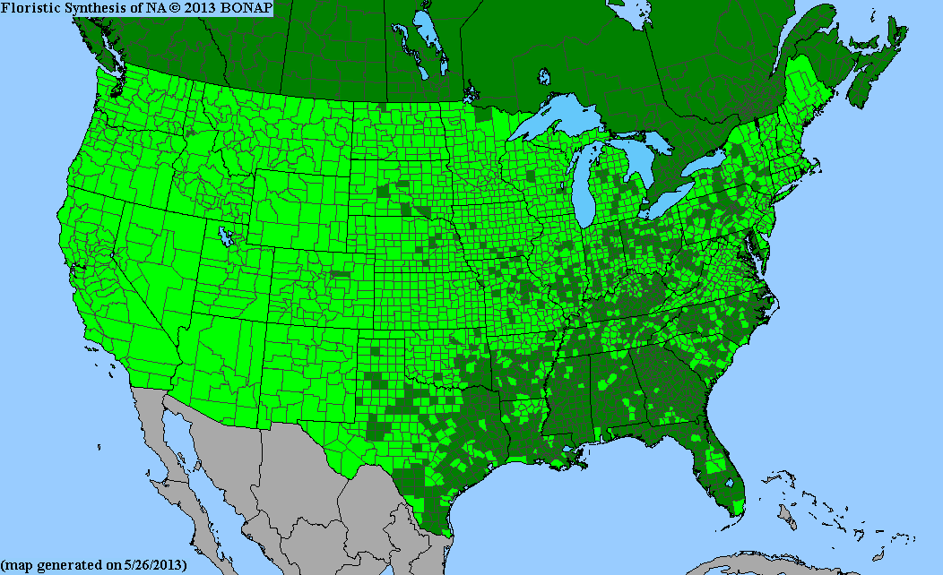

Artemisia Bonap

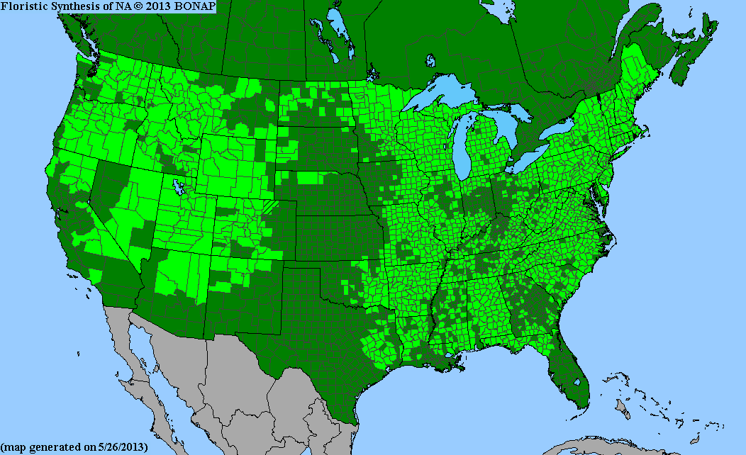

Betula Bonap

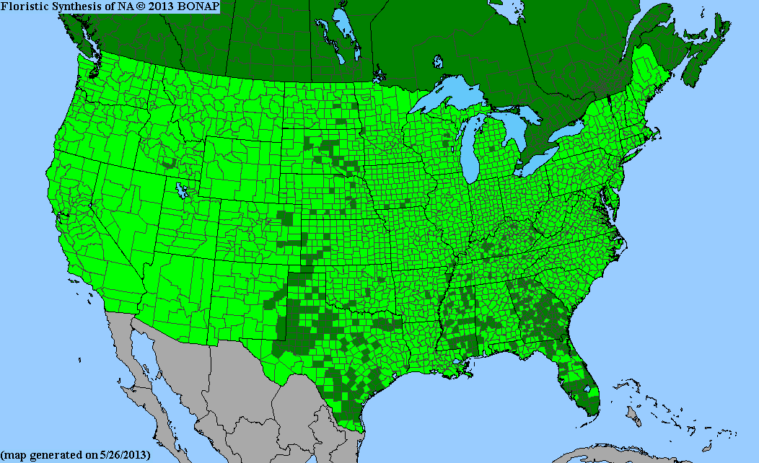

Poa

Pollen allergies would often cause hypersensitivity syndromes in human body, including asthma, rhinitis and conjunctivitis, which appear in the same patient simultaneously during the pollen season (Sofiev, Belmont , etc. , 2013 ).The key role in the pollen allergies mechanism is the IgE(antibody immunoglobulin E), which is a class of antibodies in humans. Human body would overproduce IgE in response to the exposure of allergenic pollen in the membranes lining the nose. The allergens then attach to the IgE on the surface of certain immune cells, which would release chemicals that can cause inflammation and increase mucus in human airways. Allergenic rhinitis symptoms may begin, such as rhinorhea, nasal obstruction, nasal iching and sneezing (Brozek, Bousquet 2010)

Sensitization occurs at the site of primary allergen exposure, i.e. airways, but can also occur through dermal contact. However, not everybody who is exposed will become sensitized and have allergic reactions. Aside from the individual exposure conditions, there is high variability in individual responsiveness to a given allergen dose.

* http://www.bonap.org/map%20legend/sgreen.jpghttp://www.bonap.org/map%20legend/sgreen.jpg

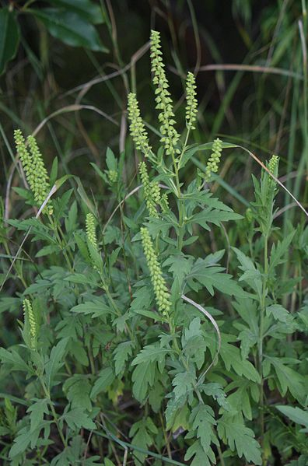

Krzysztof Ziarnek Dąbiu.Ambrosia [*Ambrosia psilostachya*](http://en.wikipedia.org/wiki/Ambrosia_psilostachya) *http://en.wikipedia.org/wiki/File:Ambrosia_psilostachya_kz1.jpg*

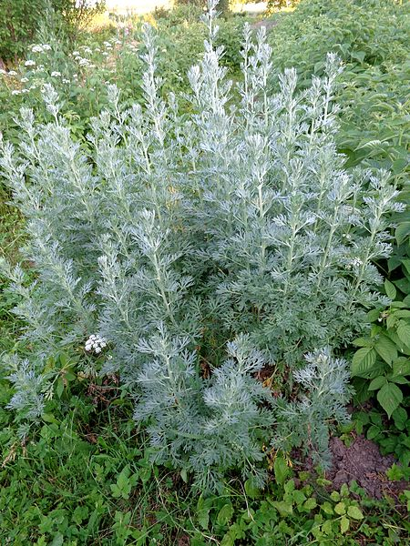

[AfroBrazilian](http://commons.wikimedia.org/wiki/User:AfroBrazilian) http://en.wikipedia.org/wiki/File:Artemisia_absinthium_01.JPG

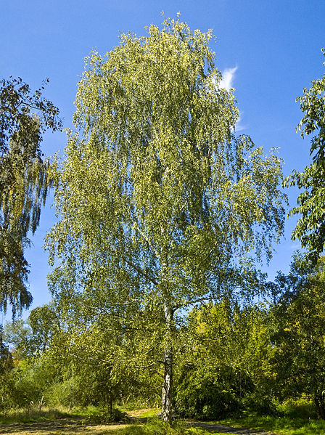

<http://en.wikipedia.org/wiki/File:Betula_pendula_001.jpg>

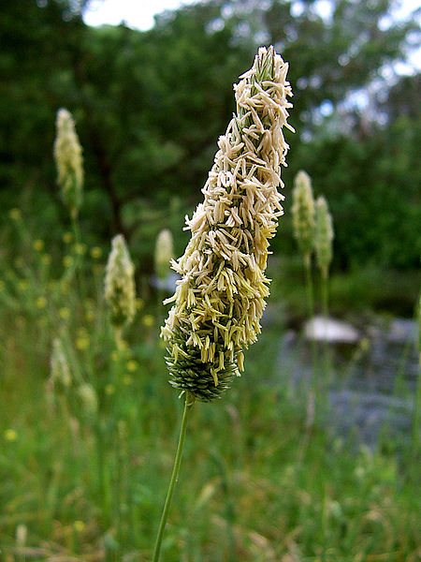

<http://en.wikipedia.org/wiki/File:Meadow_Foxtail_head.jpg>

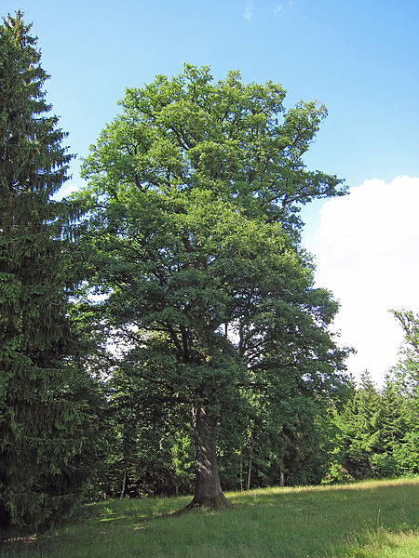

http://en.wikipedia.org/wiki/File:Eiche_bei_Sch%C3%B6nderling,_2.jpg